Introducing a new AI Agent I developed as part of my professional development.

The Zapier platform offers many templates to work with. As my first experiment, I used the Multi-Article Summarizer. For this example, Google Drive and Google Docs are the two main sources for inputs and outputs.

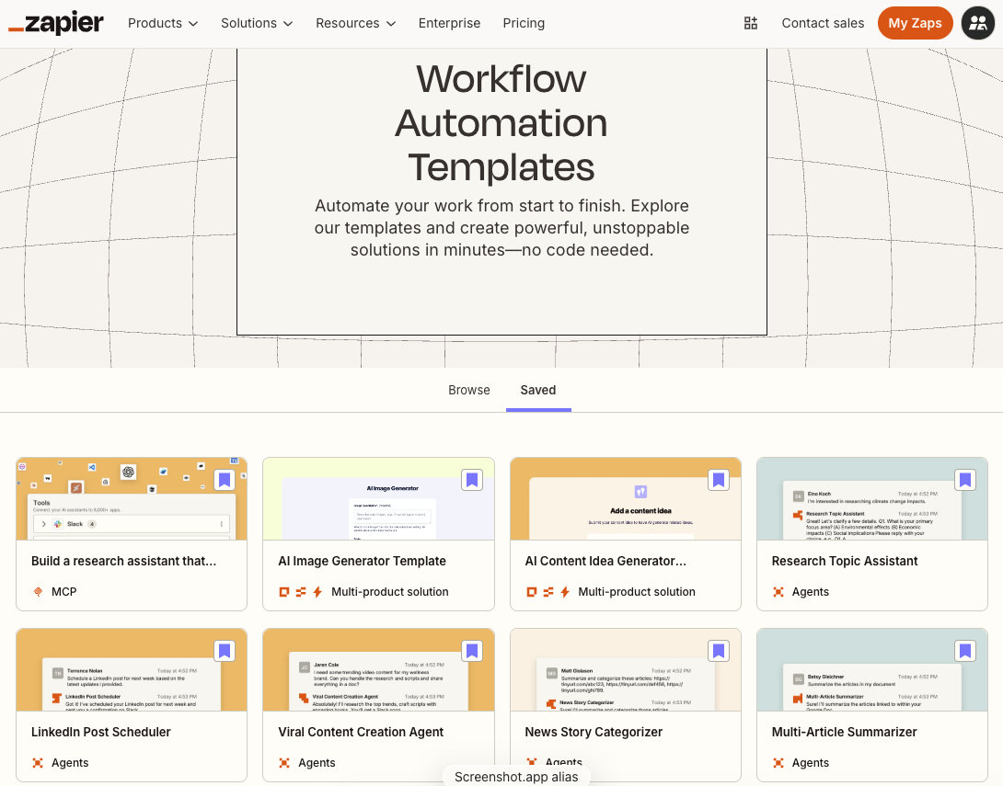

AI Agent Overview:
This agent automatically summarizes content from links in a document, generating a comprehensive summary in a Google Doc.

Benefits of the Multi-Article Summarizer template:
This agent efficiently gathers and summarizes information from multiple sources using an automated template. Extracting links from a document and summarizing their content saves time and provides a comprehensive overview without the need to visit each site individually. This solution is ideal for quickly understanding and compiling information from various sources into a single, easy-to-read document.

How the template operates:
The template utilizes an AI assistant to summarize content from links within a provided document.

When a summary is requested, the assistant:

- Reads the document added as a data source.
- Extracts all the links from the document.
- Visits each link to retrieve and summarize the content.
- Compiles an overall summary of all the content.
- Generates a Google Doc with the comprehensive summary.

This process delivers a clear and organized overview of multiple sources, facilitating easy understanding and review of the information.

Here is what the AI Agent structure looks like:
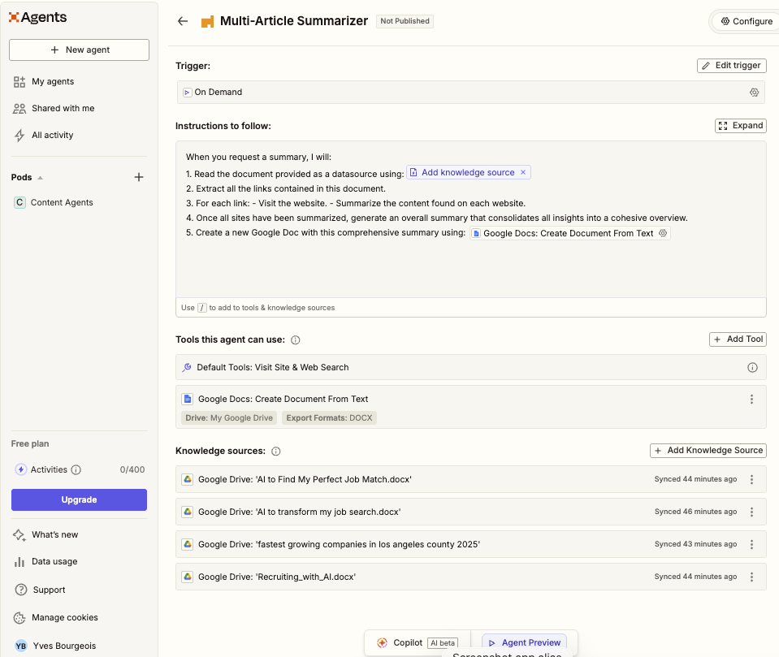

Here is what the Agent Configuration looks like:

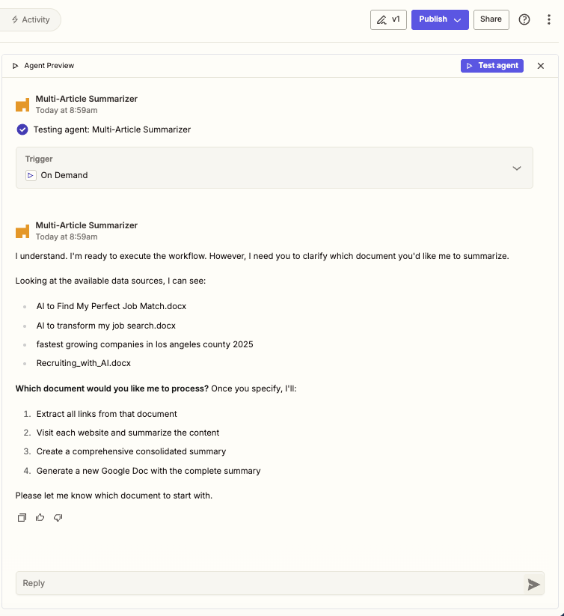

Here is what the output looks like:

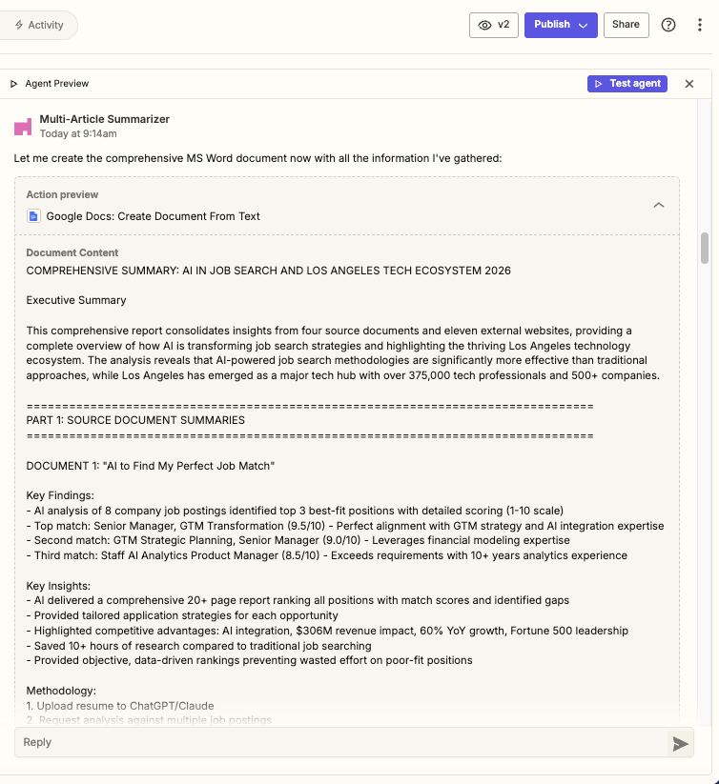

After reviewing the output, the agent asks you to approve the output generated:
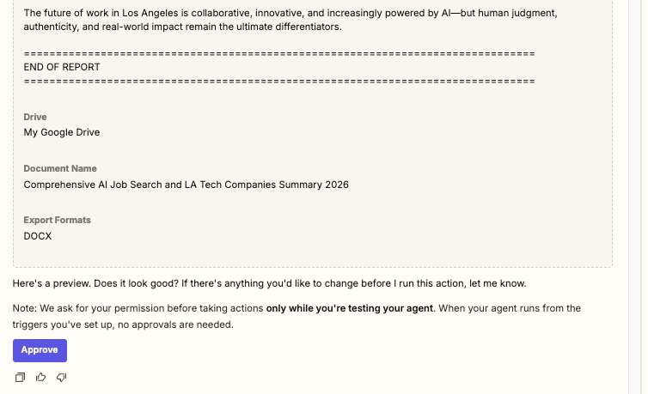

Then Zapier will generate a workflow completion summary:
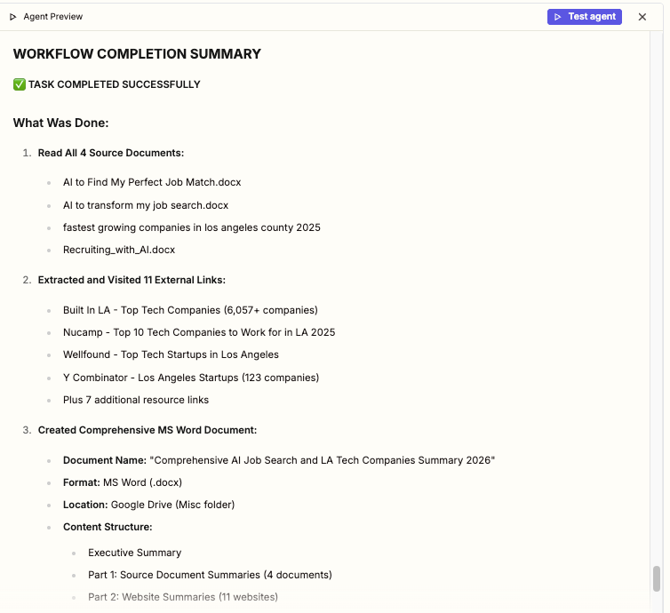
The last step is to publish your new AI agent:

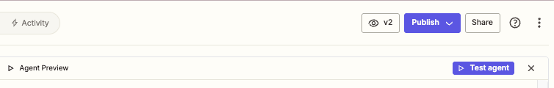
Zapier will notify you upon the completion of the publication:

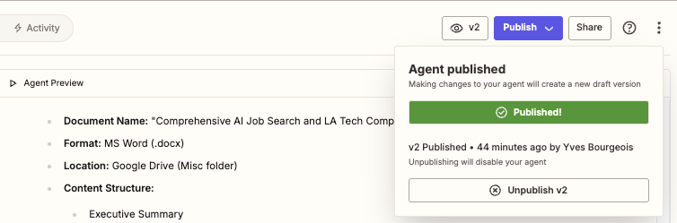

Zapier allows you to share your AI agent with other members on the platform:

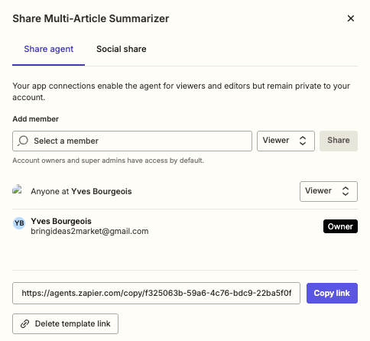

Or copy an image of the agent of social media:

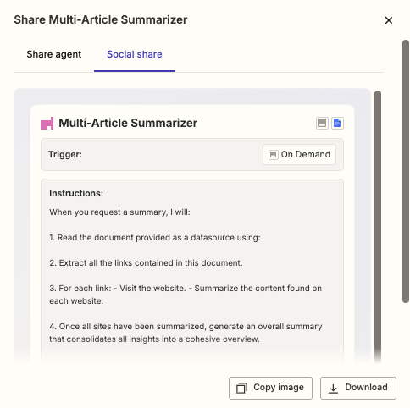

The workflow does not work perfectly. Despite requiring an MS Word output format, the agent defaults to HTML. You must specify the MS Word format again when the agent asks you which documents to process. Overall, the AI agent works very well and saves the output to my personal folder on G-Drive.

